**OPEN SOURCE GRAPHICS**

**AND**

**ANIMATION TOOLS**

**Mid term phase - 1(gimp)**

**(Doraemon Characters(5))**

**Submitted to:**

Dr. Durgansh Sharma

**Submitted by:**

Tushar Goyal

Roll no: 72

Sap ID: 500068373

B. Tech CSE (OSOS)

COMPUTER SCIENCE & ENGINEERING



**School of Computer Science**

**University of Petroleum and Energy Studies,**

**Dehradun – 248007: Uttarakhand**

**TABLE:**

|  |  |  |  |
| --- | --- | --- | --- |
| **Sr No.** | **Content** | **Page no.** | **Date** |
| 1. | Phase-1 (GIMP)- Doraemon 5 characters | 1-7 | 4 March 2020 |
| 2. | Phase-2 (Blender)- UPES 11 Block |  |  |

**PHASE -1**

**DoREMONS CARTOON CHARACTER MAKING ALL STEPS:**

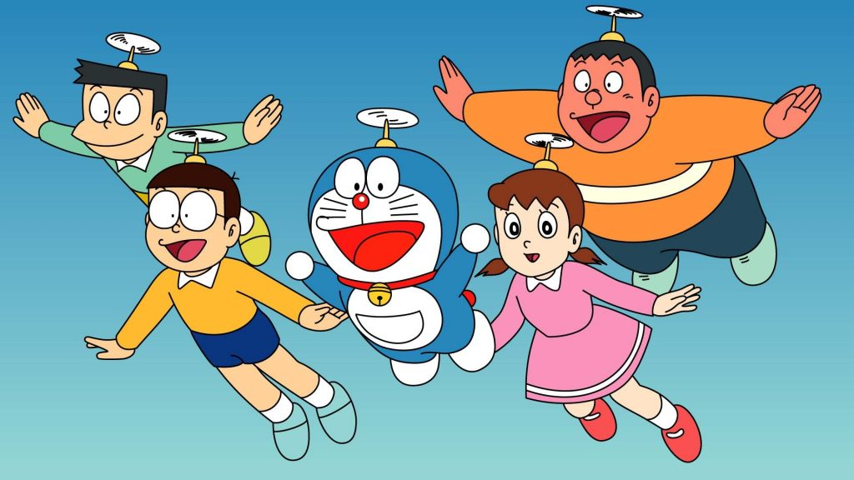***STEP 1:*** Select a picture to draw.

***STEP 2:*** Open GIMP.

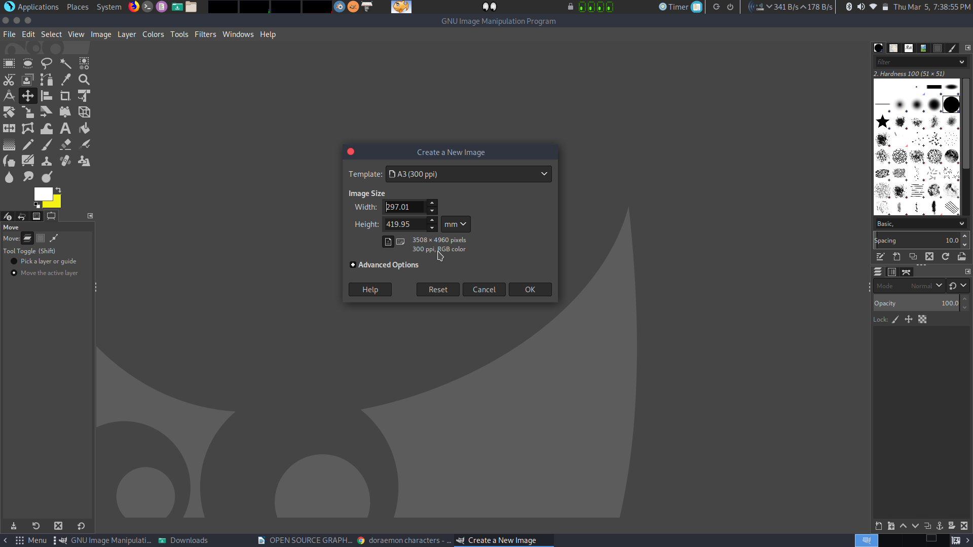***STEP 3:*** Create a new file Size: A3(297.01mm * 419.95mm).

***STEP******4:*** Select Image tool(in menu bar)> then select transform option and then rotate it 90 degree clockwise.

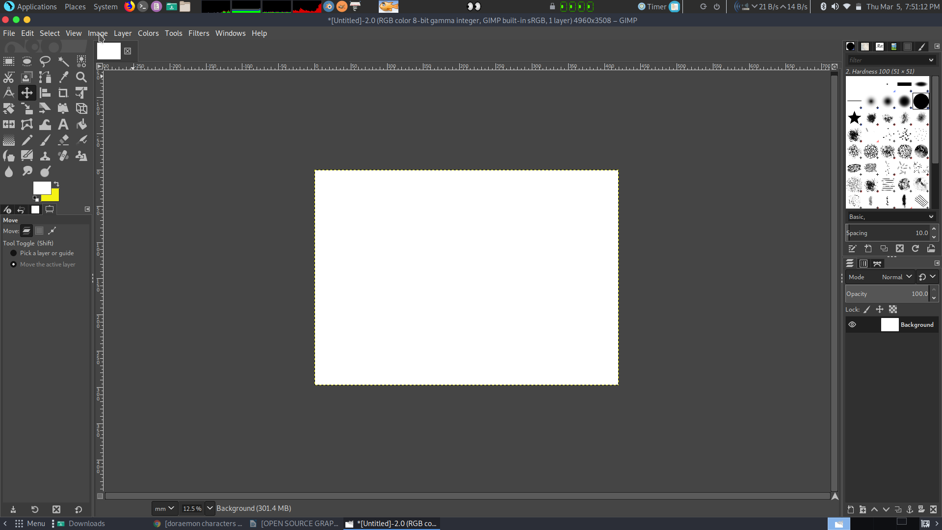***STEP 5:*** Draw the outline of Cartoon with the help brush or pencil tool.

***STEP 6:*** After completion of outline then select that part using selection tool and make it a new layer.

***STEP 7:*** Then adjust it's size using scale layer option.

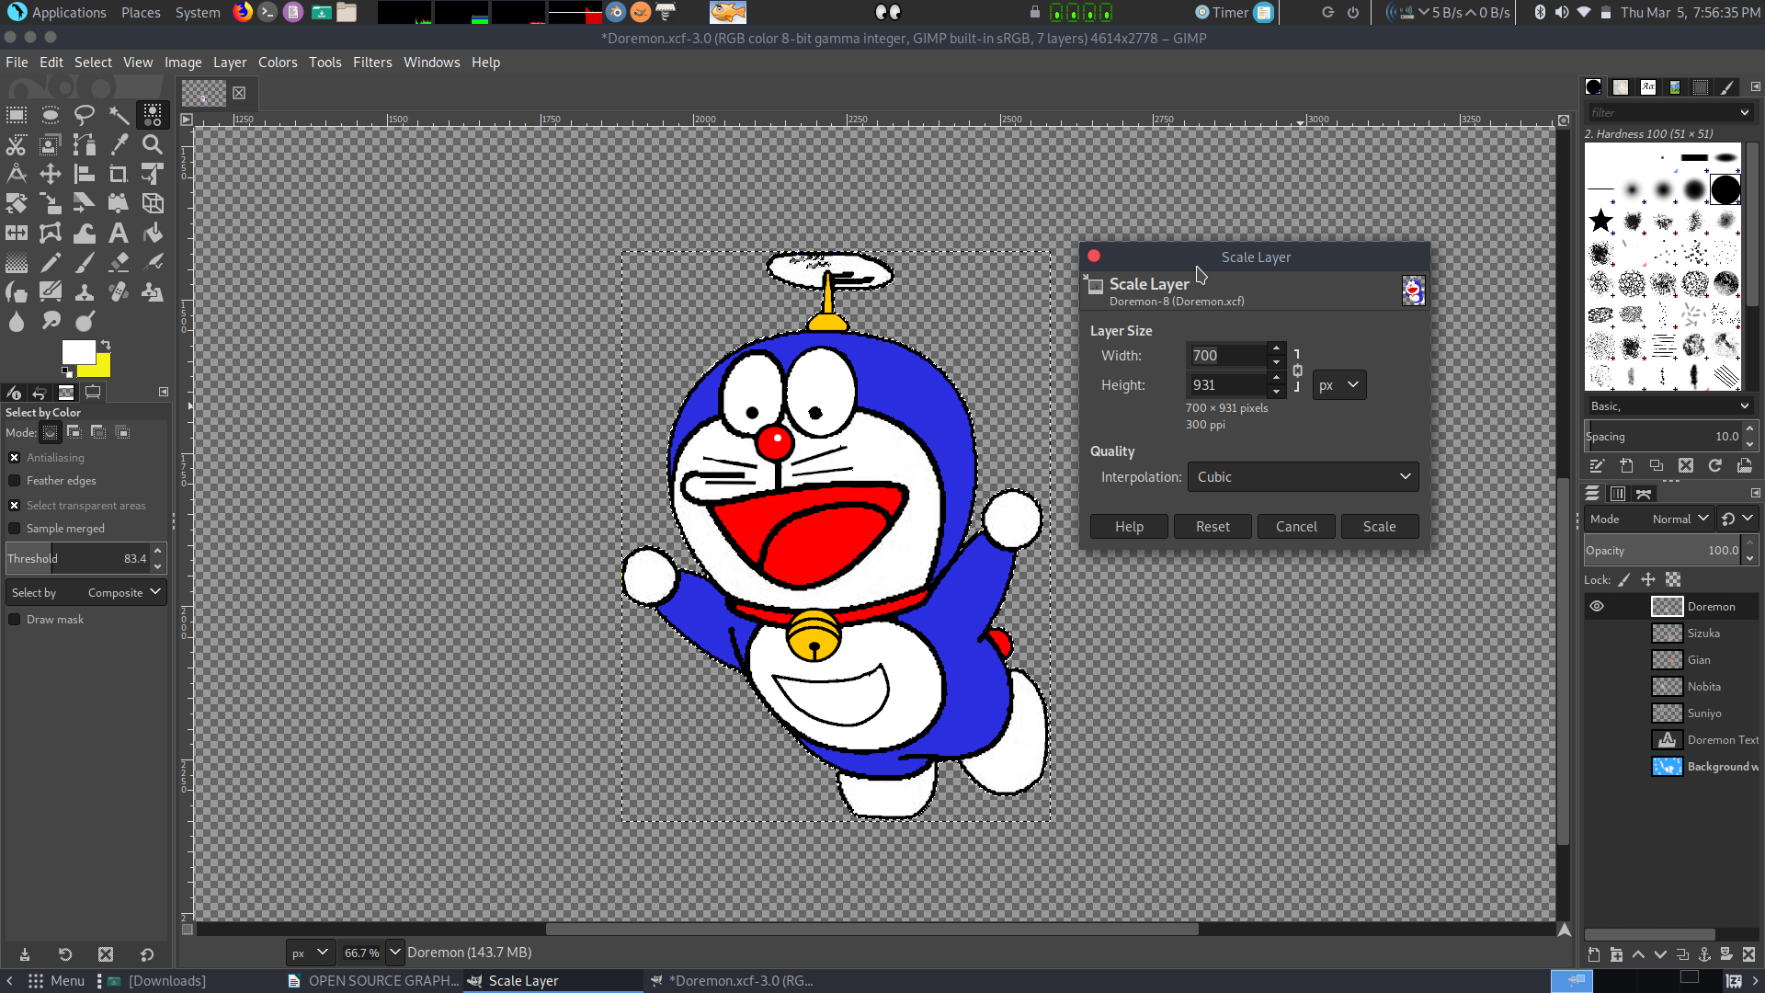

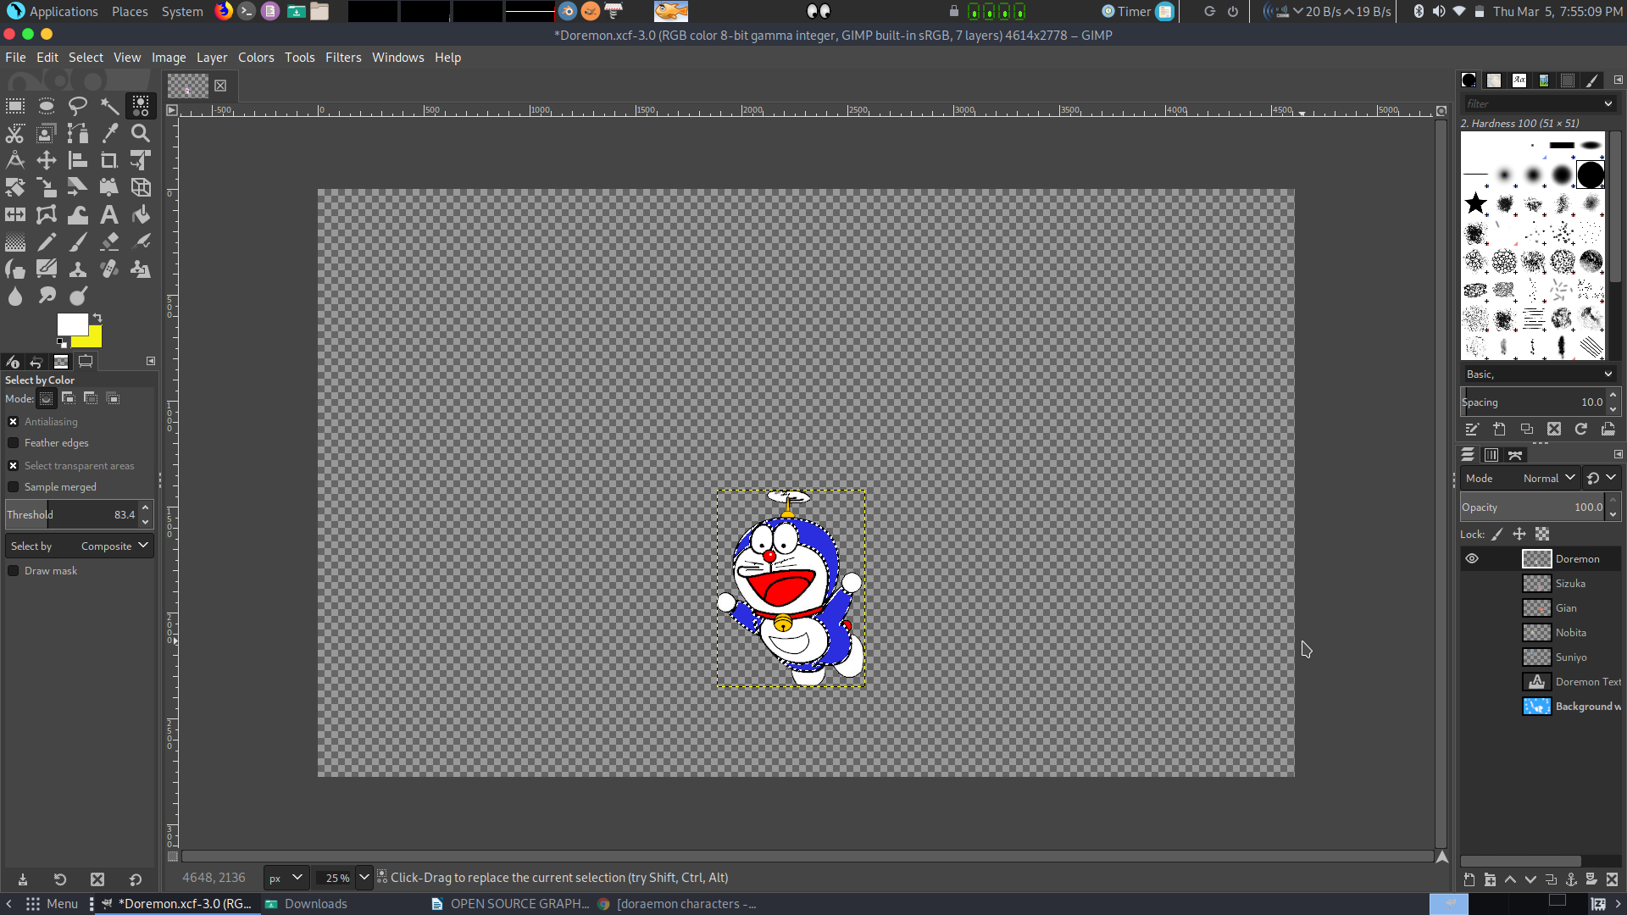***STEP 8:*** Then make inner outline of that cartoon using pen or pencil.

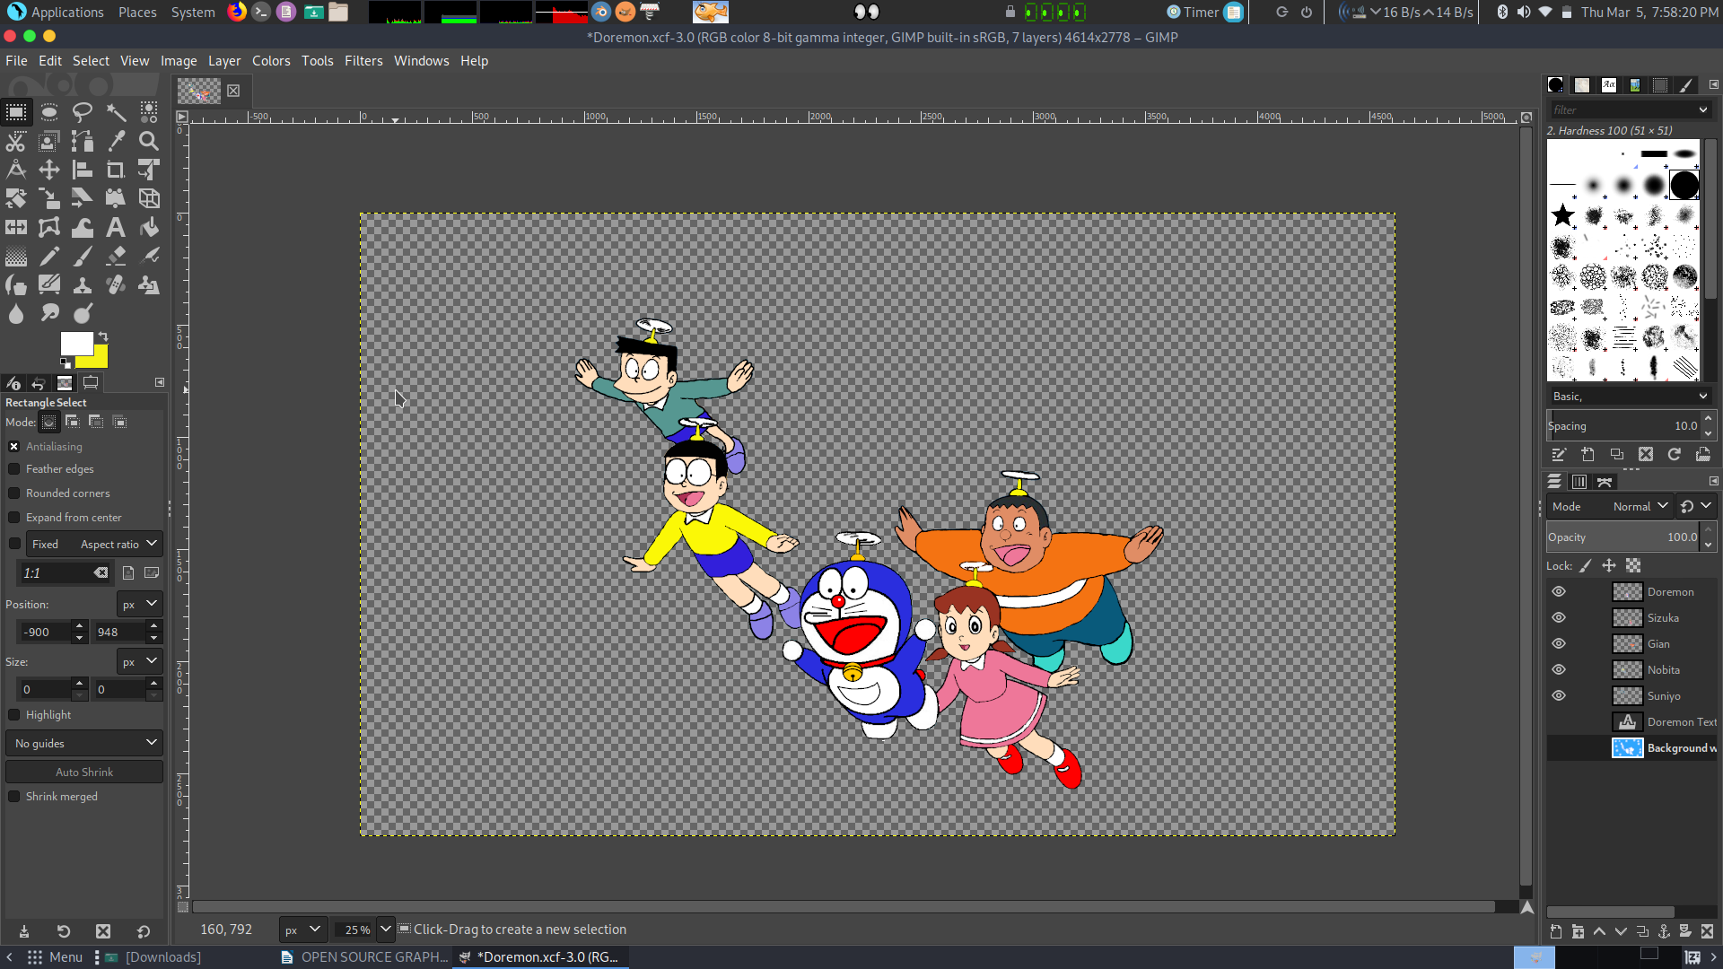***STEP 9:*** Repeat step 5-8 to make all the 5 cartoons (Doraemon, Nobita, Sizuka, Suniyo, Gian).

***STEP 10:*** Then I get 6 Layers: Background,Doremon, Nobita, Sizuka, Suniyo, Gian.

***STEP 11:*** Then select one layer and using selection tool(Fuzzy , Ellipse) and select a area of cartoon which I want to color.

***STEP 12:*** Open Chrome then search eye droper extension for chrome and add it to chrome.

***STEP 13:*** Search that Cartoon picture and open it on chrome. Use Eye droper extension to check that color code of Cartoon and copy that code.

***STEP 14:*** Open GIMP, open color management and Selet HTML Notation Option then paste code of color there.

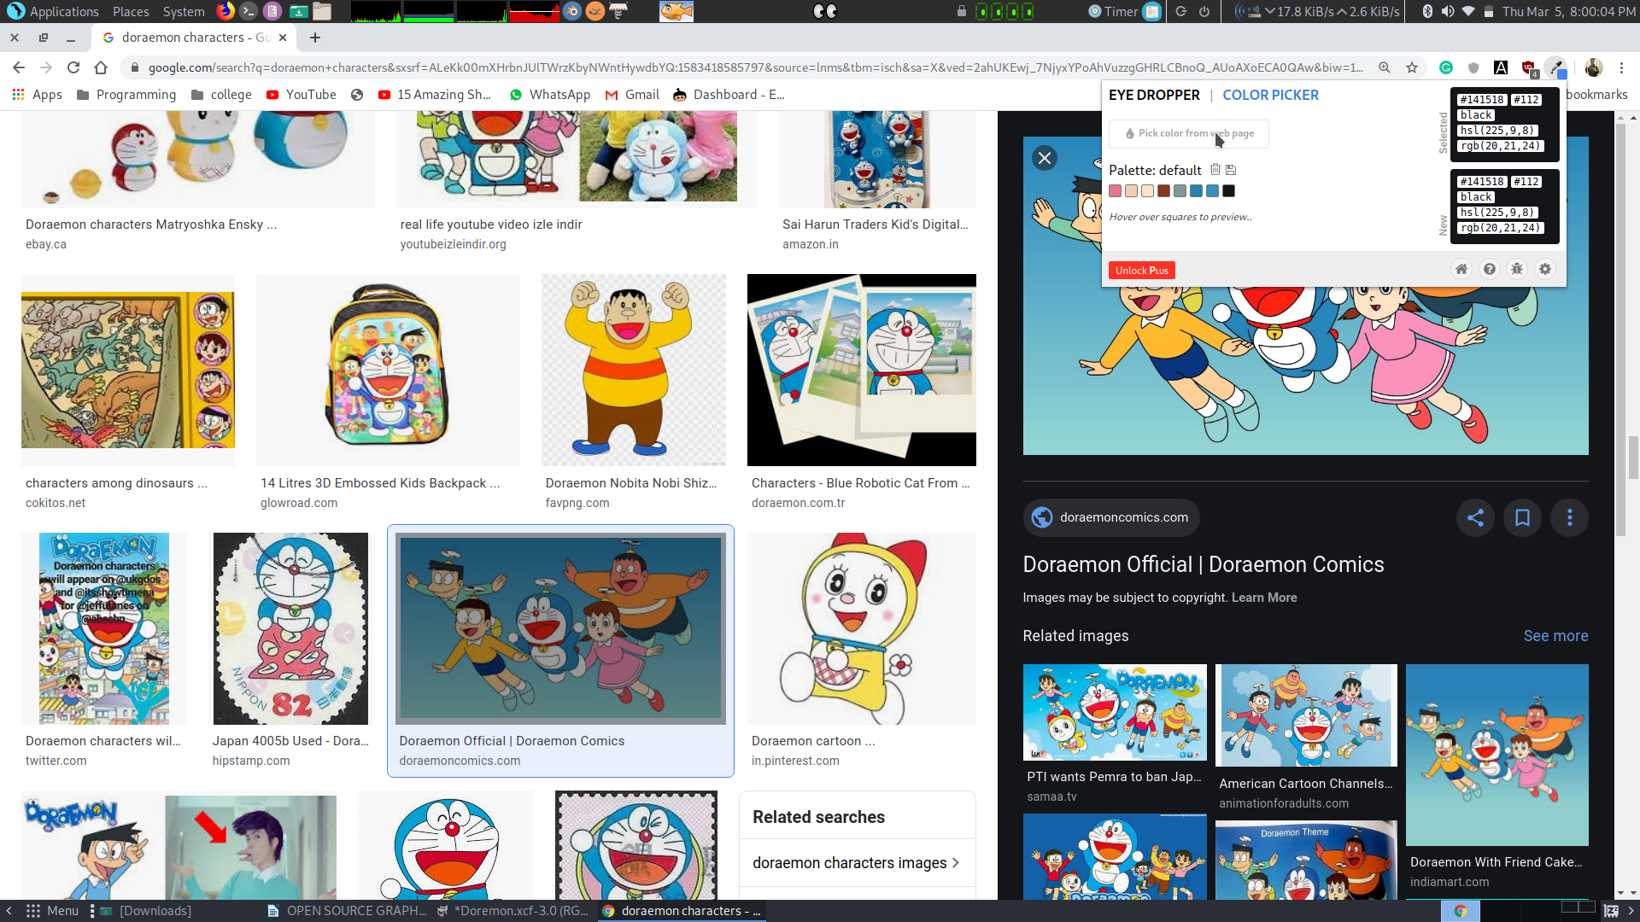

***STEP 15:*** Then use Bucket fill tool and fill that area which I select to fill color.

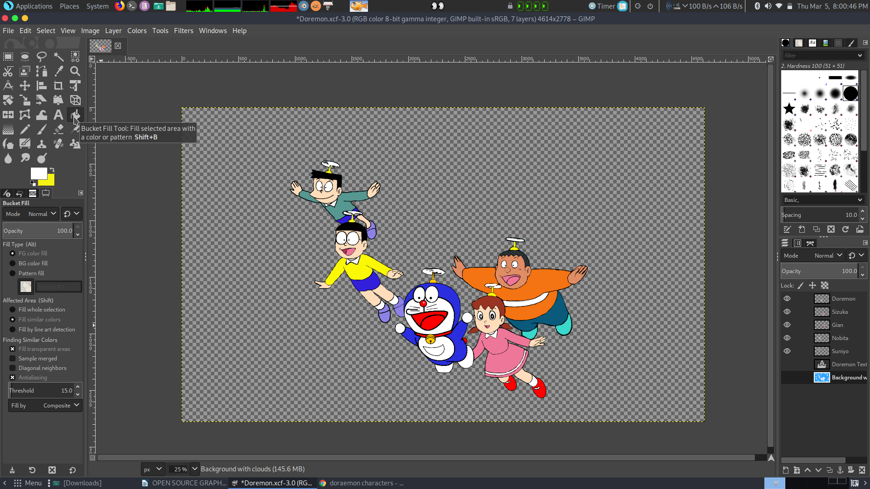

***STEP 16:*** Repeat Step 12-16 untill All character are colored.

***STEP 17:*** Select Background Layer: then pick a Sky Blue color and then select bucket fill tool and then fill the background color.

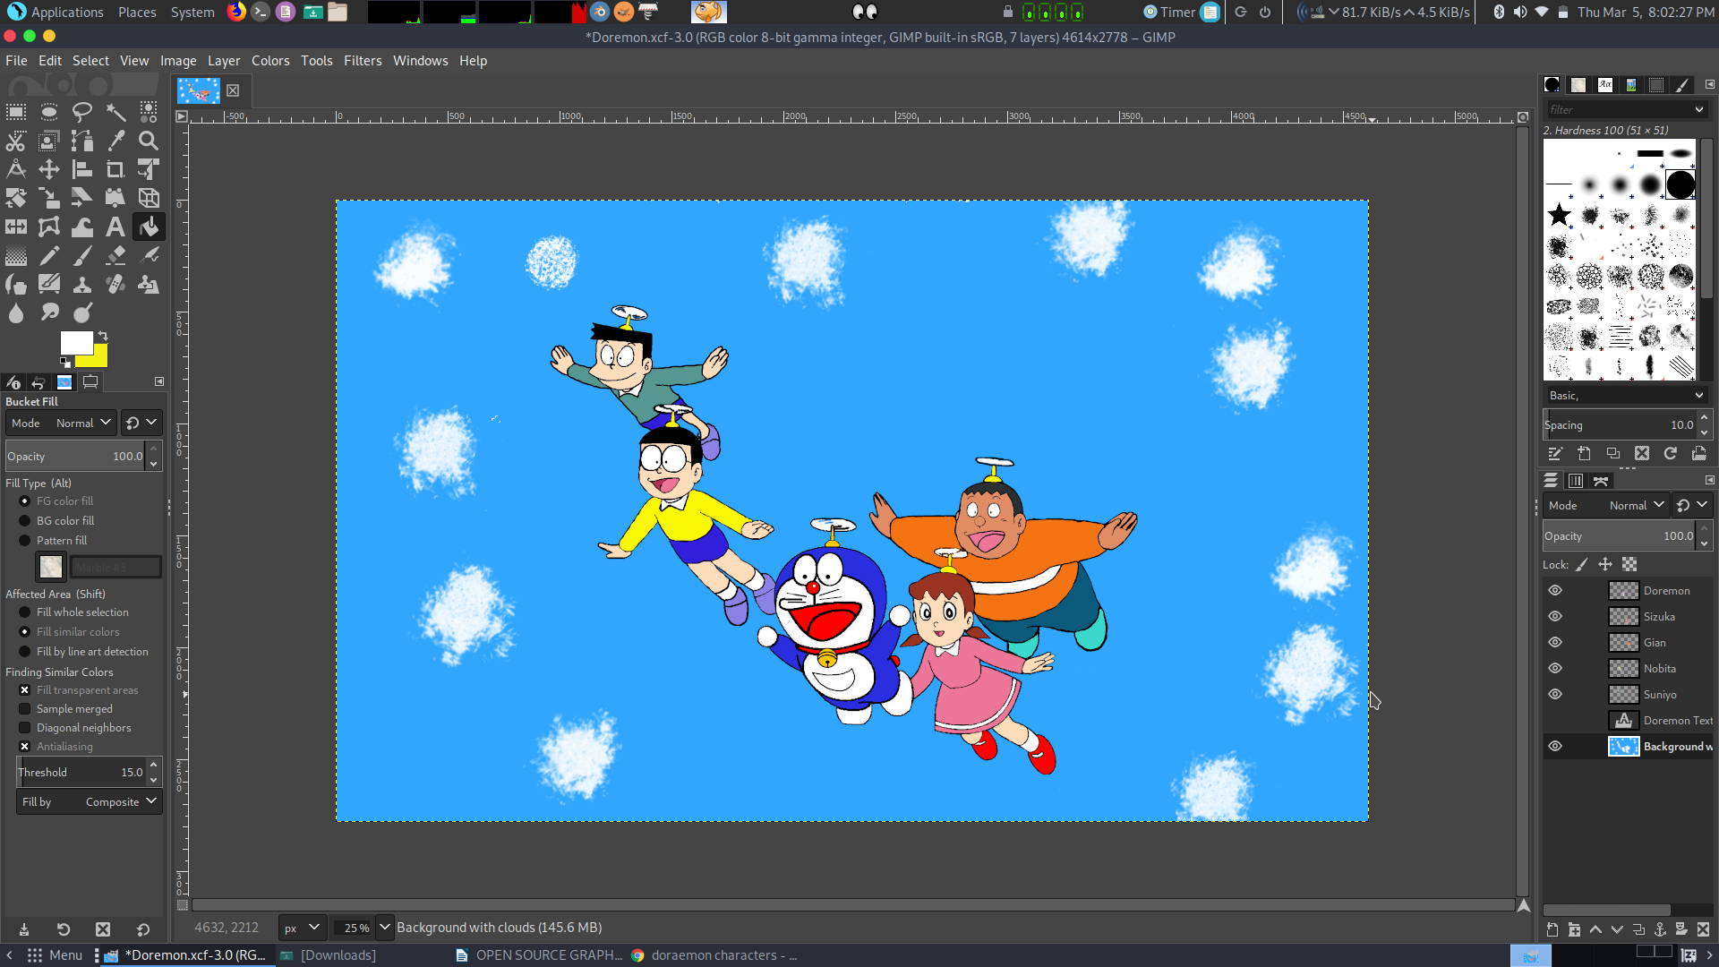***STEP 18:*** Then Use Eraser and go to tool bar then select any brush style, then erase some portion from background. (To make Clouds).

***STEP 19:*** Pick Text Tool then select a area where I want to Write.

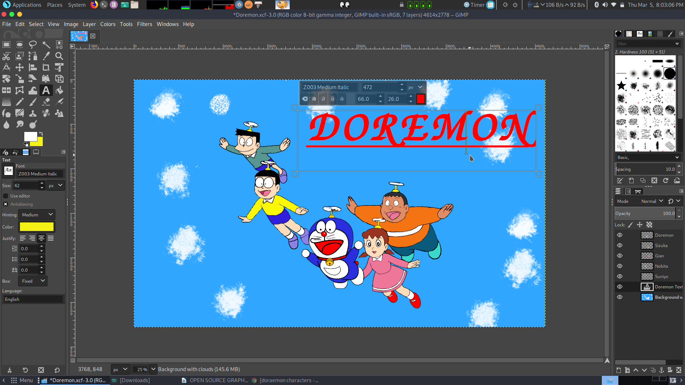***STEP 20:*** Write a DORAEMON and then adjust its size and Kerning, Baseline, Spacing(From right sides tool bar) and select Italic and Bold Option.

***Text Typefaces details:-***

Kerning: 26.0 Spacing: 20.0 Basline: 66.0

***STEP 21:*** Write a DOREMON, Nobita nobi, Sizuka Minamoto, Suneo, Takesi Godo and then adjust its size and Kerning, Baseline, Spacing(From right sides tool bar) and select Italic and Bold Option.

***STEP 21:*** Go to Image option in menu bar then Select flattern image option for combine all Layers.

***STEP 22:*** To save as JPEG format: go to file option in menu bar. Then select Export option then save it as a JPEG format. Then save it.

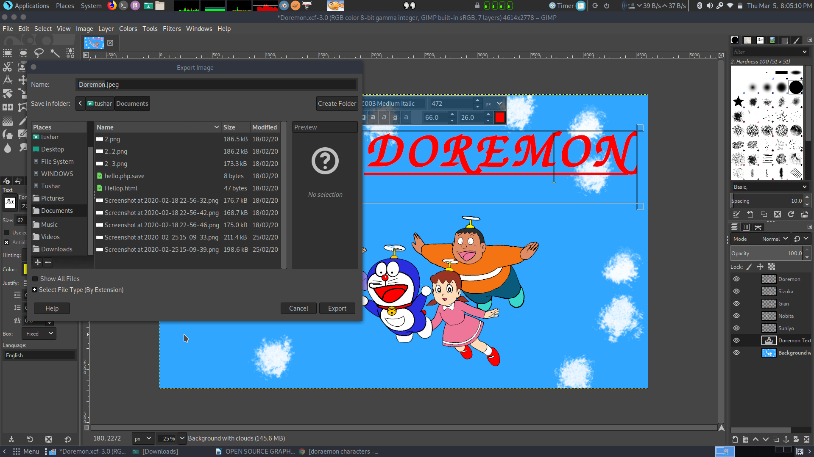

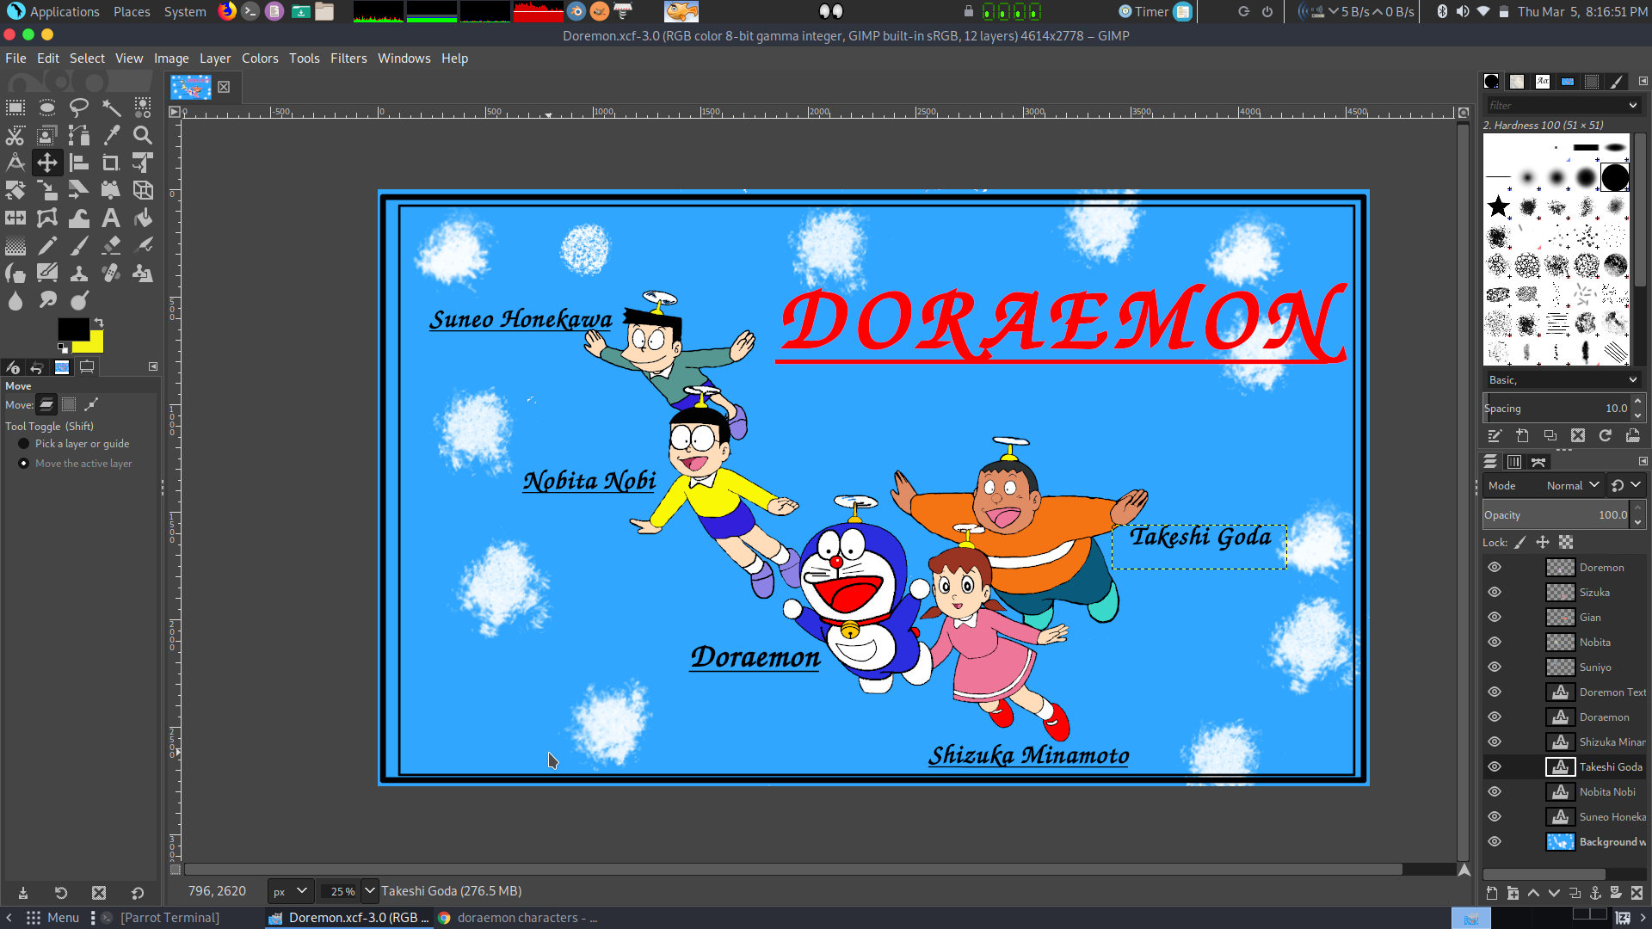

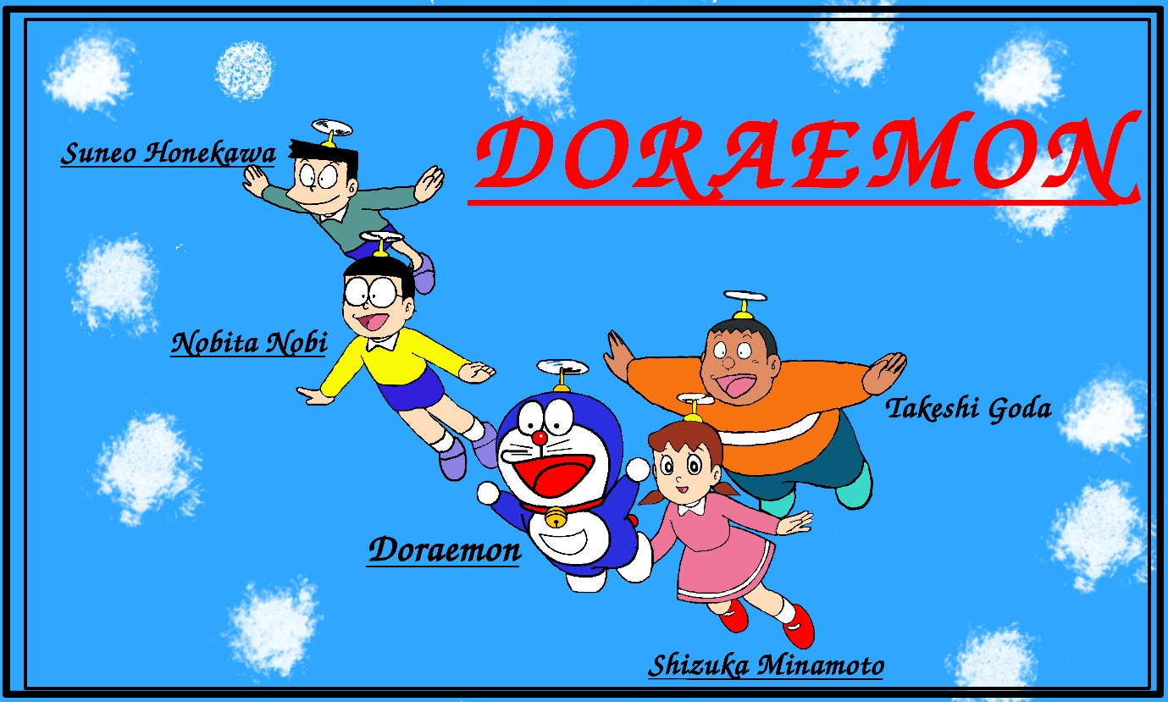**FINAL IMAGE:**

***Text Typefaces details:-***

Kerning: 26.0 Spacing: 20.0 Basline: 66.0

I used these typography as a good look to me.